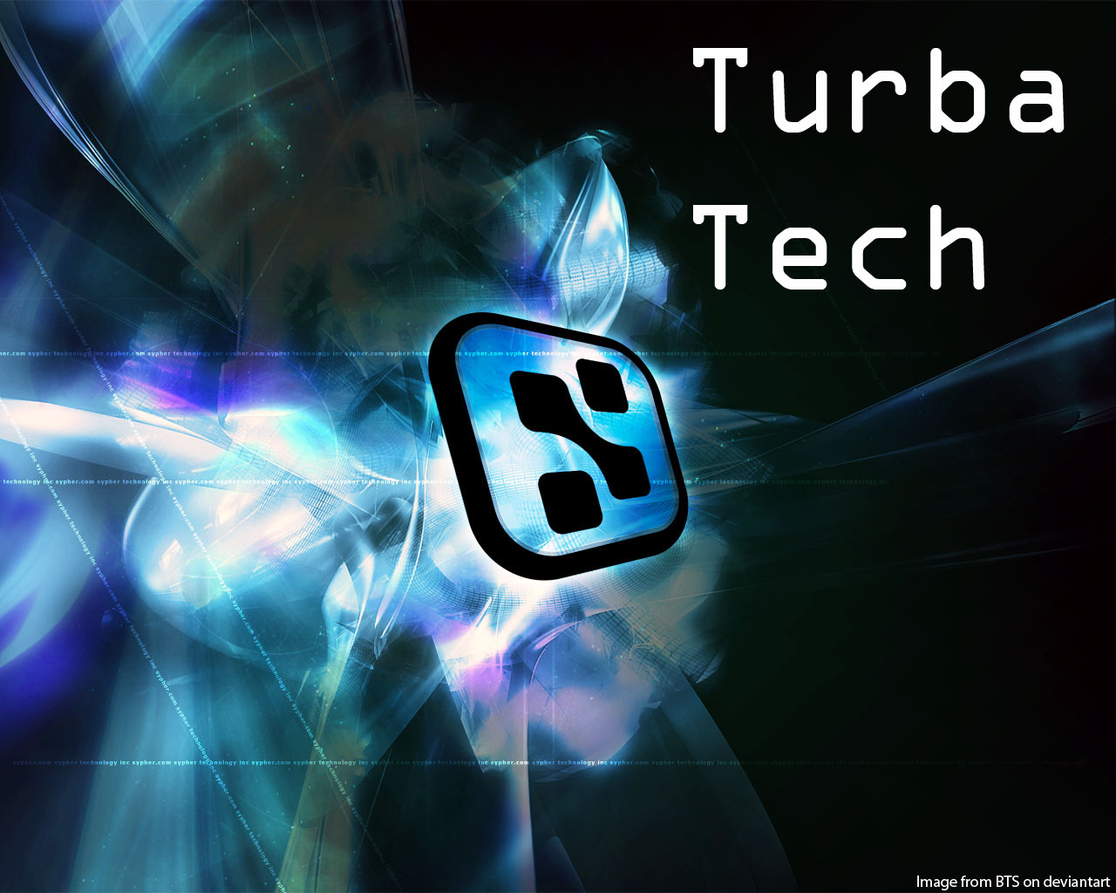
Software Engineering
User Stories Document

William D. Whelchel II
Gerald I. Ottman III
Philip Knouff
Michael D. Bristol II
Randy Akers
Radford University
Department of Information Technology
http://php.radford.edu/~softeng12
10/27/2011

Revisions

Version | Primary Author(s) | Description of Version | Date Completed
1.0 | William Whelchel  Phillip Knouff | Creation of the User Stories Document, adding User Stories. | 11/01/2011

Review & Approval
User Stories Document Approval History
Approving Party | Version Approved | Signature | Date
Dr. T. L. Lewis | 1.0
Customer (SPSC) | 1.0

User Stories Document Review History
Reviewer | Version Reviewed | Signature | Date
William D Whelchel II | 1.0 |  | 11/1/2011
Gerald I. Ottman III | 1.0 |  | 11/1/2011
Philip Knouff | 1.0 |  | 11/1/2011
Michael D. Bristol II | 1.0 |  | 11/1/2011
Randy Akers | 1.0 |  | 11/1/2011

Contents

Team Information 3
TurbaTech 3
OpenHack 3
Project Objectives 3
Project Scope 3
User Stories 3

Team Information

TurbaTech
TurbaTech is a five person team of students at Radford University. The team consists of students who are pursuing careers in the Information Technology field and are all taking Software Engineering II.

OpenHack
OpenHack is a piece of software that will be written in python and will bring down instances at random on Rackspace’s OpenStack Framework. OpenHack is based on the open source Chaos Monkey.

Project Objectives

Turba Tech will provide the client with a version of OpenHack that is compatible with Rackspace’s OpenStack framework. They will also provide the client with a reporting functionality to monitor the effect of Chaos Monkey on their systems, as well as the health of those systems after Chaos Monkey has been unleashed.

Project Scope

The system will be interpreted into python to be compatible with the OpenStack framework. The system will only work on servers that are running OpenStack and are allowed by a user or system admin. When running, the system will shut down random processes on a specific server.

User Stories

